Warning – Traction Control Always On – CGEA 1.3

Functional Description

The purpose of the Traction Control Always On Warning is to inform the MyKey Restricted User that the MyKey Administrator has configured the Traction Control System to always be on. This information is displayed in the Message Center if the MyKey Restricted User attempts to disable the Traction Control System via the Traction Control switch. (i.e. this warning is displayed on the Message Center display whenever the TC_Always_On_MC_Status_Flag = Active).

Since some vehicles do not have AdvanceTrac standard, we use the configuration parameter TC/IVD/RSC to select either the text of "AdvanceTrac" or "Traction Control". Also note that for vehicles with 4x4 Low, when in 4x4 Low mode this warning is not displayed. (Since stability control is disabled when in 4x4 Low)

The TC switch is read by the cluster. This is defined in the TC-ESC-RSC Switch section of this SPSS.

The TC_Always_On_MC_Status_Flag status flag is defined in both the TC-ESC-RSC Switch section of this SPSS and the U22x_U37x_MyKey_TC Switch section of this SPSS. Only one of these will apply to a given vehicle platform.

Interface

Interface Context Diagram (I/O Block Diagram)
Figure 1 Warning – MyKey Traction Control
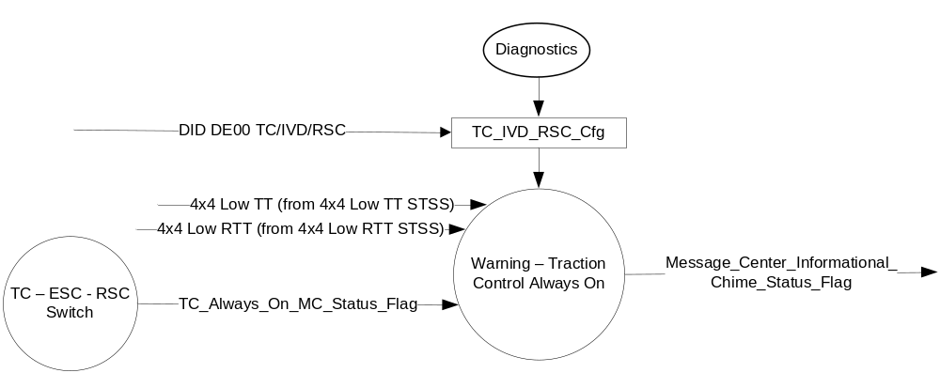

Inputs

- TC_Always_On_MC_Status_Flag.
See the TC – ESC – RSC Switch section of this SPSS or the U22x_U37x_MyKey_TC Switch section of this SPSS for definition of the state of this flag.
      - TC_IVD_RSC_Cfg (See ESC Telltale STSS)
      - 4x4_Low_Telltale (See 4x4 Low TT STSS)
      - 4x4_Low_RTT (See 4x4 Low RTT STSS)

Outputs
- Warning Message W890 or W891
For definition of W890 and W891, see the X Display Y x Z Text Message List section of this SPSS (where X, Y, and Z are appropriate values in this document).
- Message_Center_Informational_Chime_Status_Flag

Function/Performance

Operational Modes

Mode | Differentiating Vehicle Conditions
Sleep Mode | OFF
Limited Mode | OFF
Normal Mode | MyKey TC Always On Warning Text Message OFF/ON
Crank Mode | MyKey TC Always On Warning Text Message OFF/ON

Voltage Levels

Refer to the Cluster Features Table located in the Operational Modes and Voltage Range Strategies Section of this SPSS

Human-Machine Interface

Visual

Indicator Graphics / Display Format
Message Center Text Warning Message as defined in section 1.3.5.7 of this document.

Indicator Color Coordinates

Reference section COLOR & ILLUMINATION REQUIREMENTS (GRAPHICS).

Audio

The Message_Center_Informational_Chime_Status_Flag is associated with this Warning.

Switch Control Logic

None.

System Accuracy

Within 100 msec of receiving a message that results in a change of state the cluster will update the output flag to the proper state.

Operation: Performance and Functional

Subsystem Algorithm Flowchart / State Diagram

Table 1.1 TC_Always_On_MC_Status_Flag to MC Warning Message ID
TC_IVD_RSC_Cfg | TC_Always_On_MC_Status_Flag | 4x4_Low_TT /  4x4_Low_RTT* | MC Warning Message ID | Active Chime_Status_Flag
0x2 (IVD) or  0x3 (RSC) | Active | OFF/INACTIVE | W890:  ADVTRAC ON  MYKEY SETTING | Message_Center_Informational  _Chime_Status_Flag
0x1 (TC) | Active | OFF/INACTIVE | W891:  TRAC CNTRL ON  MYKEY SETTING | Message_Center_Informational  _Chime_Status_Flag

Note: 4x4 Low TT and RTT logic only applies to clusters with the 4x4 Low indication feature (i.e. trucks).

Operation Description (supports algorithm flowchart /state diagram)

- For definition of how the Message Center arbitrates and displays Active warnings, see the Warning / Alert Display Logic Diagram, located in the Message Center – X Display with W Button Interface section of this SPSS (where X and W are appropriate values in this document).

Function Safety Classification (EMC)

Class B

Memory Storage

Not Applicable

Prove Out

No.

Reconfigurable Telltale

No.

Message Center Msg

Warning Message ID W890 or W891, as defined in the Text Message List section of this SPSS.

Error Handling

Not Applicable

Diagnostics

Self Test

None

Engineering Test Mode

Not Applicable

Part II Performance

Not Applicable

Reference Specification

Not Applicable
SPSS Module Revision History

Revision Level | Name | Change Description | Date
1.0 | V. Patel | Updated for CGEA1.3. Based on CGEA Warning - Traction Control Always On STSS V2.0  No updates required, except renaming the document to include CGEA1.3 | 5/11/2010
2.0 | S. Watkins | Catch-up to CGEA version 3.0.  Section 1.3.1 Operational modes: for Crank, changed “off” to “off/on”  Updated for vehicles that support 4x4 Low mode (i.e. trucks such as F-150, F-350). Per Alex James, when in 4x4 Low mode, the AdvanceTrac (stability) control is disabled. Similarly, on a F-350 dually with EOTC (Engine Only Traction Control), when in 4x4 Low mode, the traction control is disabled. Thus, on any vehicle, when in 4x4 Low mode, the MyKey warning for AdvanceTrac always on or Traction control always on should NOT be displayed.  - 1.1 – Update description to describe 4x4 Low mode  - 1.2.1 – Update Context Diagram to add 4x4_Low_TT and 4x4_Low_RTT  - 1.2.2 – Update to add 4x4_Low_TT and 4x4_Low_RTT  1.3.5.1 – Update Table 1.1 to add logic for 4x4_Low_TT and 4x4_Low_RTT | 7/9/2012
2.1 | Ilopezla | This Update is to inform which Chime Status Flag is associated with this warning as per Global_Msg_List_ver32_Released_6_24_2015(all changes are highlighted in light blue)  Figure 1 - Added Message_Center_Informational_Chime_Status_Flag  Section 1.2.3 Added Message_Center_Informational_Chime_Status_Flag  Section 1.3.3.2 Update to Message_Center_Informational_Chime_Status_Flag  Section 1.3.5 Updated Table 1.1  Changed column’s name from “MESSAGE_CENTER_CHIME  (MC Informational – See Chime Arbitrator)” to “Active Chime_Status_Flag”  Added Message_Center_Informational_Chime_Status_Flag to Table 1.1 | 1/5/2016

